Bhartiya Institute of Engineering & Technology, Sikar
Theory of Computation (Sub Code: 6CS3A)
Question Bank

UNIT I
Q.1 Define DFA, NFA & Language?
Q.2Convert the following NFA into an equivalent DFA.
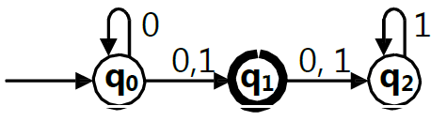

Q.3Construct the minimum state automation equivalent to the transition diagram.
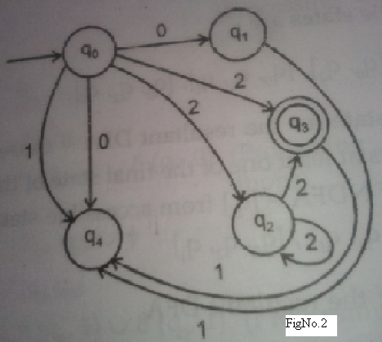

Q.4 Differentiate between Moore Machine and Mealy Machine?

Q.5 Consider a Mealy machine given by transition diagram .Construct a Moore Machine equivalent to this Mealy Machine.
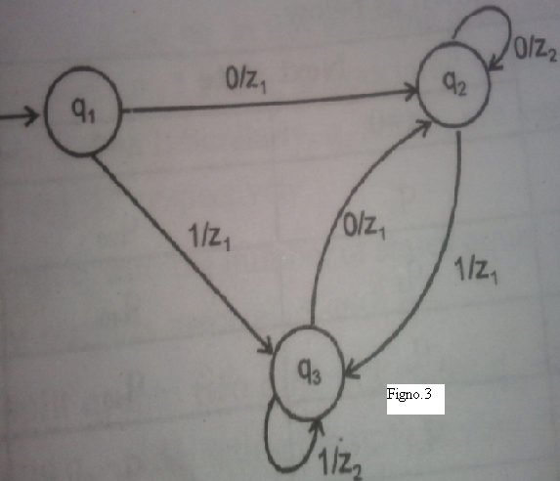
UNIT II

Q.6 Construct a grammar G generating
- L={ a^{n} b^{n} c^{n} |n >= 1}
- L=a^{n}b^{n}c^{i} |n>=1,i>=0}
- L=(wcw^{T} |w€{a,b}*}
Q.7 What is the application of regular expression?
Q.8 Construct the DFA corresponding to the regular expressions?
- 10+(0+11)0*1
- (0+1)*(00+11)(0+1)*
- (aab)*(bb+a)*
- (a(a+b)*ab

Q.9 Generate grammar for RE 0*1(0+1)*?
Q.10 What is the language accepted by the following FA?
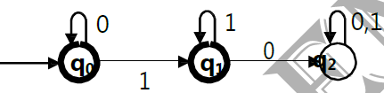
Q.11 Obtain a regular expression for the FA shown below?
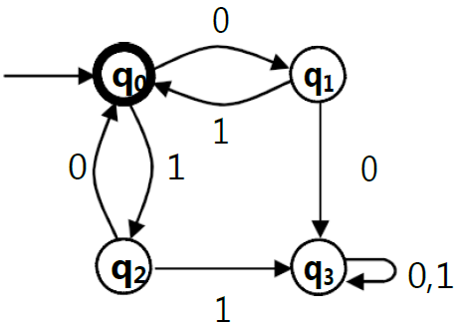
Q.12 State and explain pumping lemma . Prove that the following language L={a^{n} b ^{n} c ^{n} /
n >0 } is not CFL.
UNIT III

Q.13 Explain the Scan line method for displaying the visible surface of a given polyhedron. Consider the following S aB/bA, A aS/bAA/a, B bS/aBB/b production for the string aabbabba, Find i) Left most derivation ii) Right most derivation iii) Parse tree.

Q.14 Define Chomsky Normal Form (CNF) for context free grammar .Reduce the following grammar to CNF G= ( {S},{a,b,c},{S a/b/cSS},S)
Q.15 Prove that language L = {WW/W € {a , b}* } is not context –free .

Q.16 Construct a PDA accepting (a^{n} b^{m} a^{n} /m,n≥1} by null store . construct the corresponding context free grammar accepting the same set?
Q.17 Construct a PDA equivalent to the following grammar : S aAA, A aS/bS/a

UNIT IV

Q.18 Design a Turing machine M to recognize the language { 1^{n} 2 ^{n} 3 ^{n} / n ≥1}
Q.19Explain Turing Machine model.
Q.20 Explain Universal Turing Machine and Rice theorm.
Q.21 Design a Turing machine M to recognize the language { wcw / w (a,b)}
Q.22Compare Turing Machine to all machine in theory of computation.
UNIT V

Q.23 Explain Linear Bounded automata and its Model.
Q.24Explain Chomsky classification of language with the help of suitable example.
Q.25Explain properties of context sensitive language.
Q.26Write shote note on Recursive and Recursively enumerable language.

